**EXPERIMENT-7**

**IMPLEMENT THE BOOT SECTOR VIRUS**

**AIM:**

To implement boot sector virus.

**PROCEDURE:**

* **Update and Upgrade Kali Linux.**

Open the terminal and type in :**sudo apt-get update**.

Next, type in: **sudo apt-get upgrade.**

* **Open exploit software**

Open up the terminal and type in :**msfvenom**.

* **Fix any errors**

If you see this, it means that bundler is either set up incorrectly or hasn’t been updated.

To fix this, change the current directory (file) to usr/share/metasploit-framework by typing in:

**>>cd /usr/share/metasploit-framework/**from the root directory. If you make a mistake, you can type in

**>>cd ..**

To go back to the previous directory or type in any directory after cd to go there.

Now that we are in the metasploit-framework directory, type in

**>>gem install bundler**

To install bundler, then type in

**>>bundle install**

If bundler is not the correct version, you should get a message telling you which version to install (in this case it was 1.17.3). Type in

**>>gem install bundler:[version number]**

and then type in : **gem update –system**

After all of that, everything should work perfectly.

**>>cd /root**

to go back to the root directory.

* **Choose our payload**

To see a list of payloads :**msfvenom -l payloads**

Customize our payload

**msfvenom –list-options -p windows/meterpreter/reverse_tcp**

* Generate the virus

Now that we have our payload, ip address, and port number, we have all the information that we need.

**OUTPUT:**

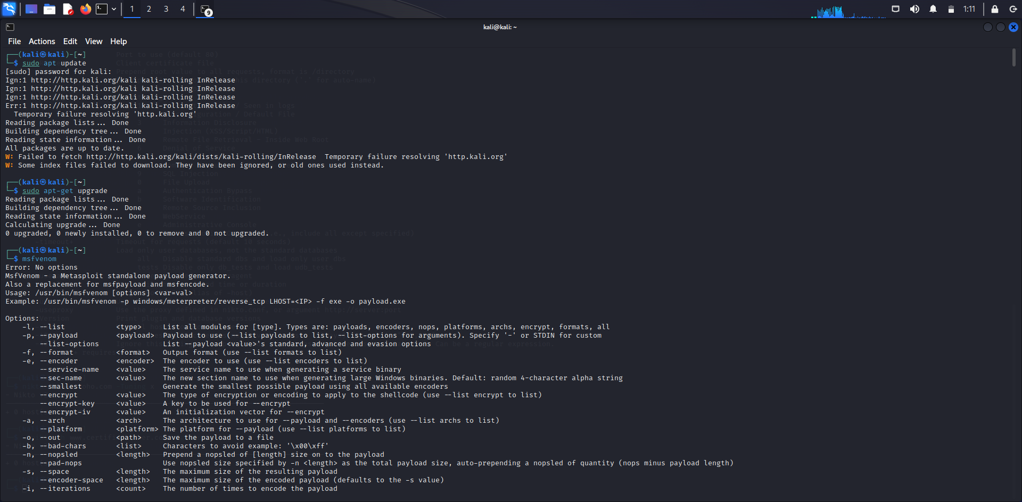

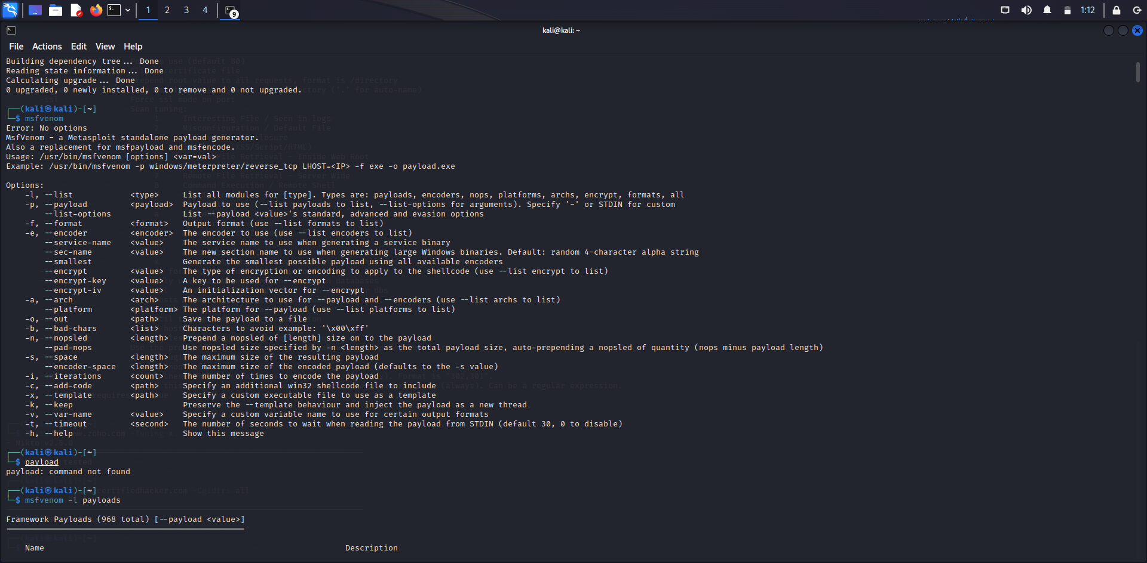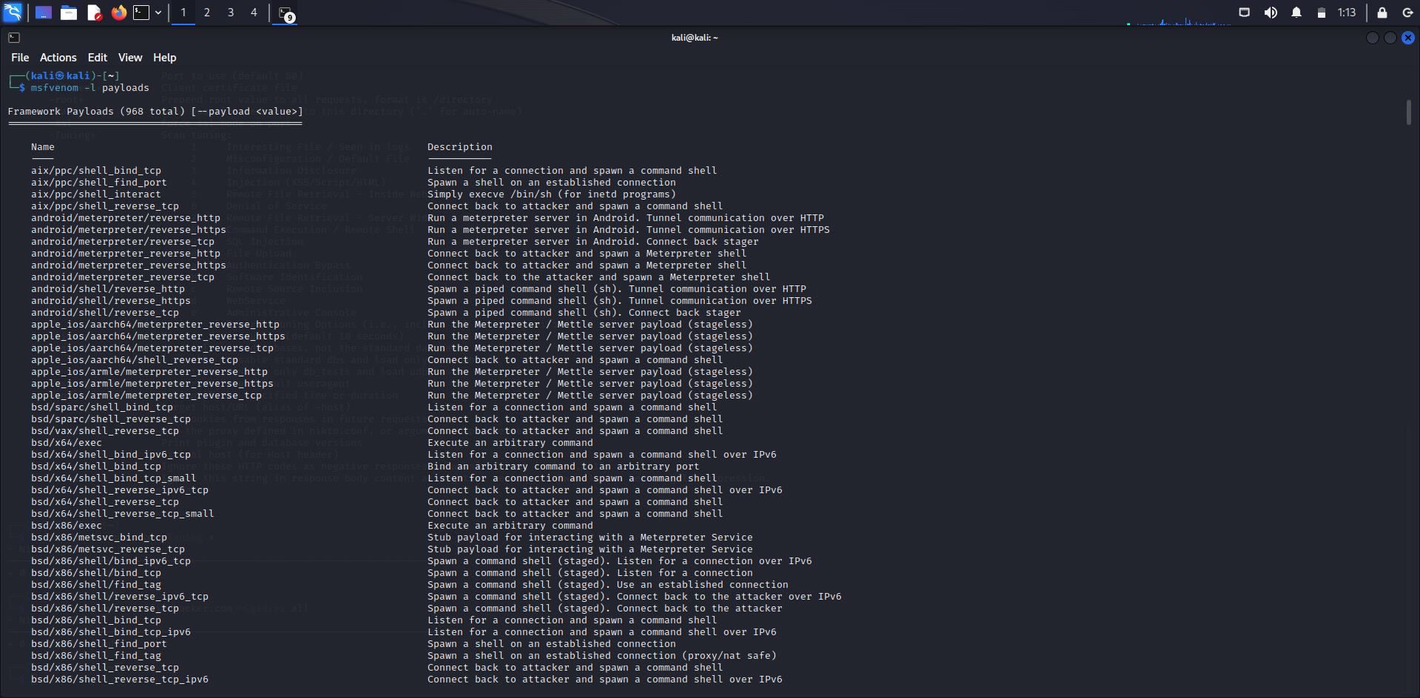

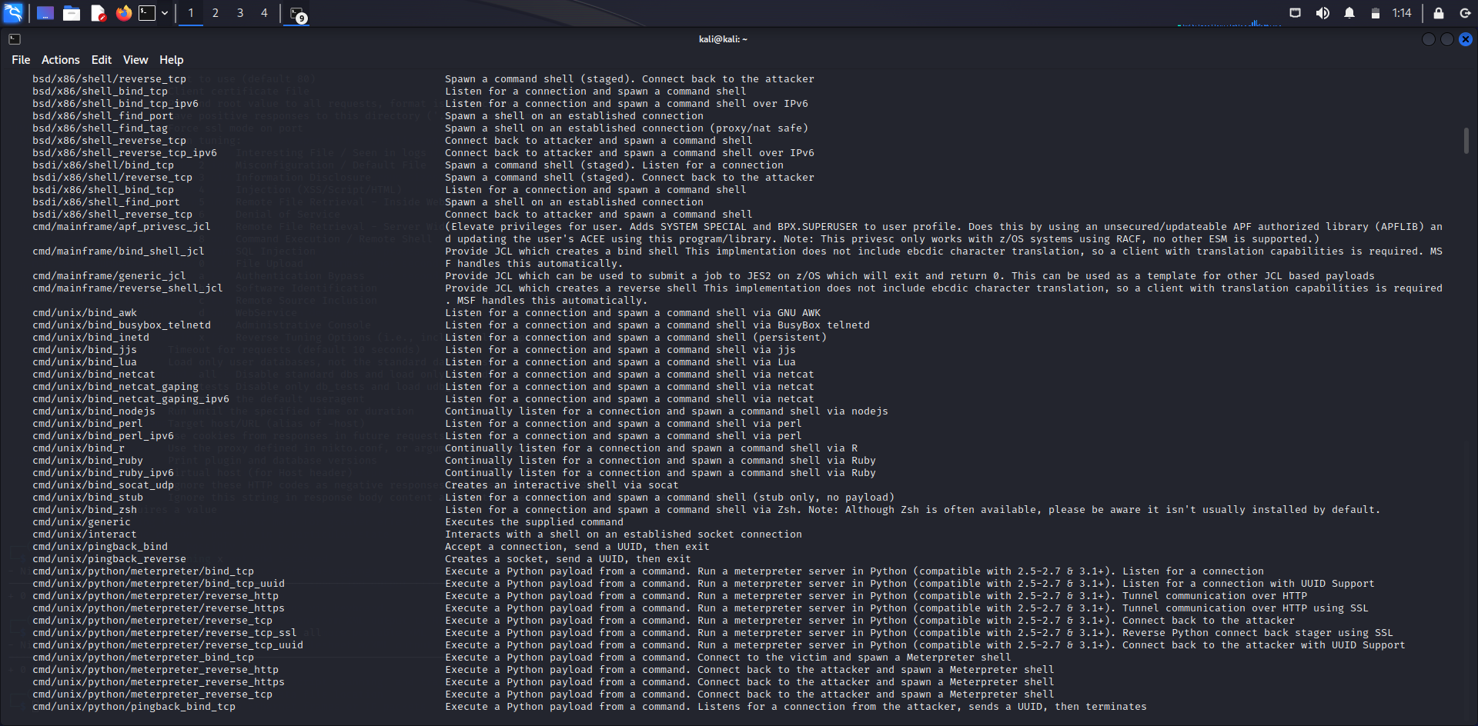

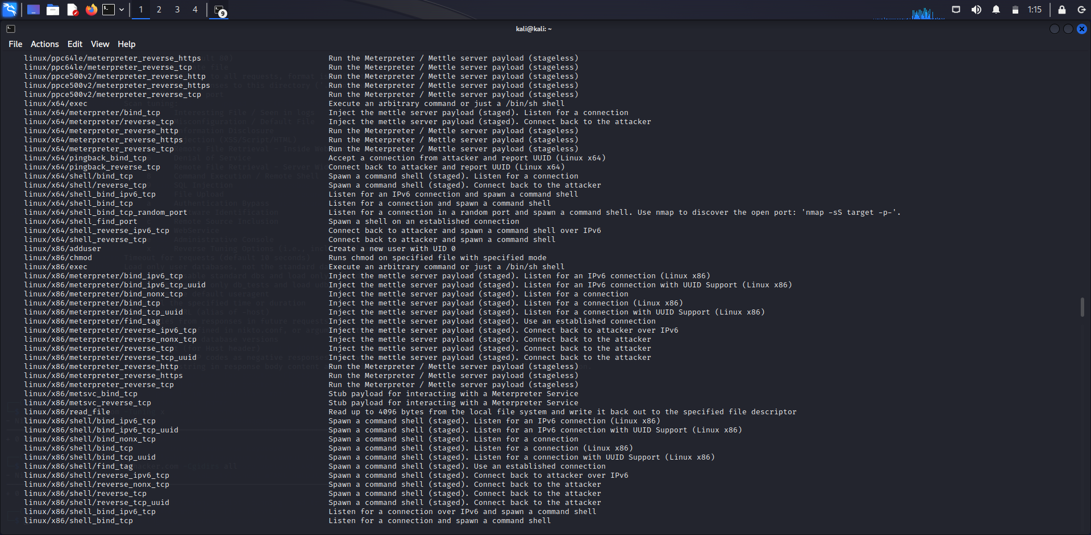

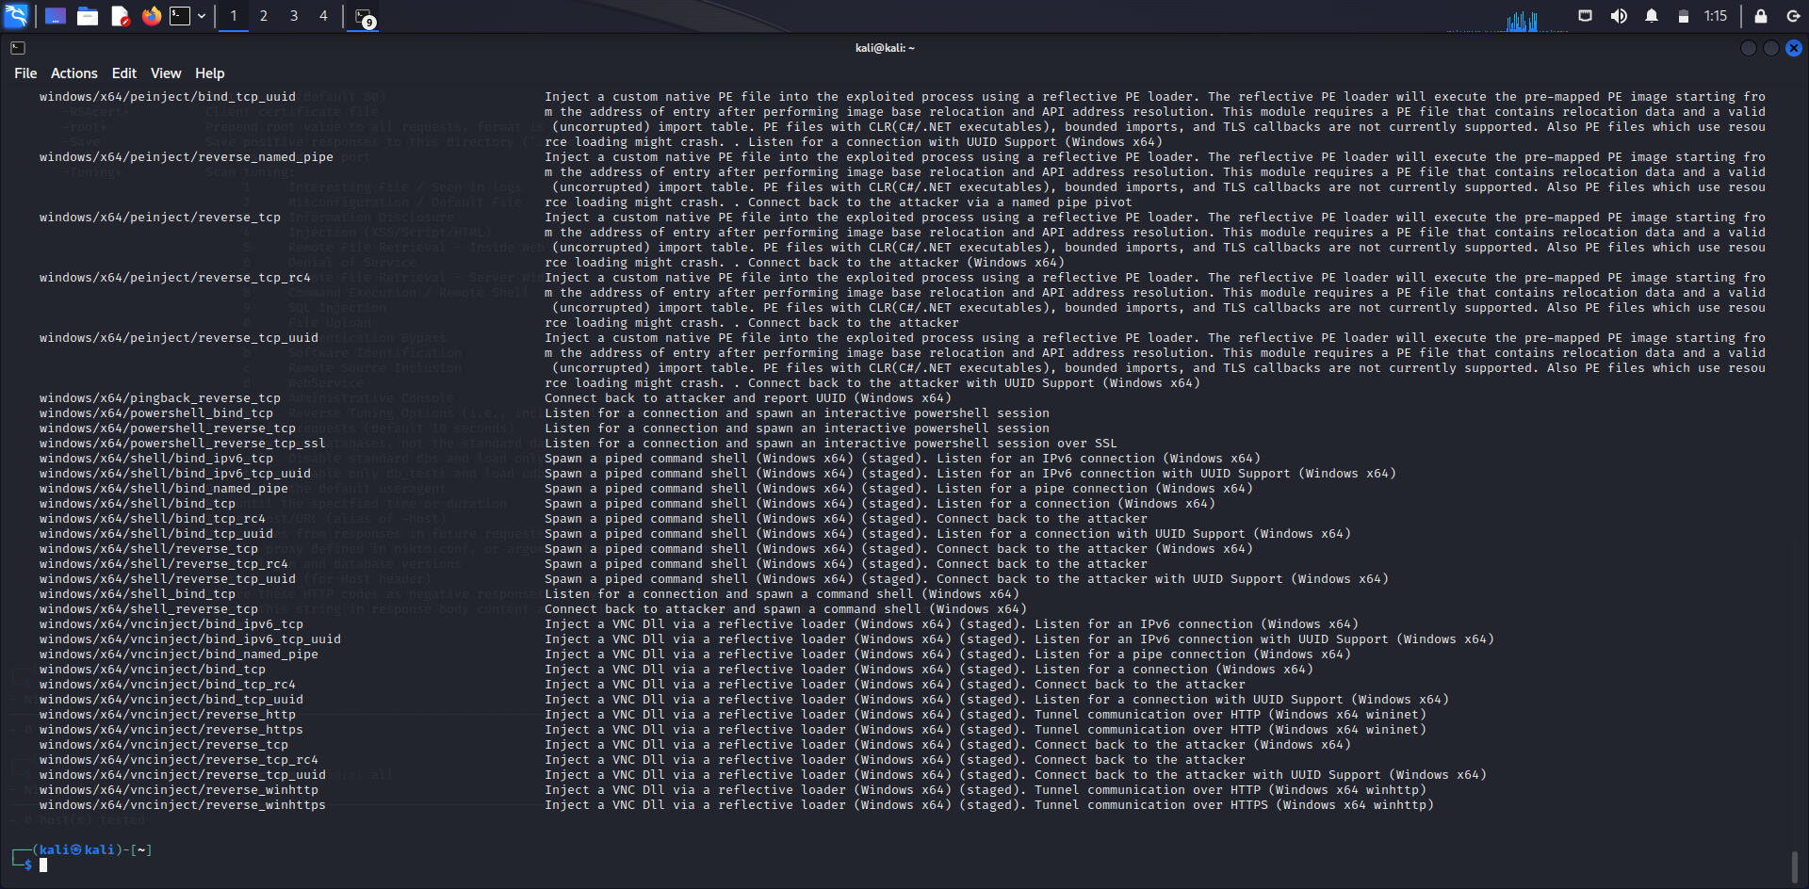

**RESULT:**

Thus the implementation of boot sector virus executed successfully.